WOMEN’S HEALTH CLINIC MANAGEMENT SYSTEM



Session: 2021 – 2024

Submitted by:
Zoya Naveed 2021-CS-201

Supervised by:
Madam Maida Shahid

Department of Computer Science
University of Engineering and Technology
Lahore Pakistan

- Description of Project
The project is a women’s health clinic management system. Admin acts as a receptionist
and can add a patient. There are four departments. In each department there are two doctors. The doctor charges varies by the doctor you choose and the number of times you have already visited the doctor. Admin can also see the record of all the patients or record of a specific patient. For users it works as an online portal of the hospital where they can book an appointment. The user also has the option to choose from four departments, two doctors each department. User can also see their previous appointments and can give their feedback as well.

- Users of the Application
It consists of two users:
- Admin
- Patient

- Functional requirements
Admin:
- As an admin I shall be able to add a Patient.
- As an admin I shall be able to view record of all Patients.
- As an admin I shall be able to change by Account Password.
- As an admin I shall be able to add special Discounts.
- As an admin I shall be able to view a specific Patient’s History.
- As an admin I shall be able to view Patient record sorted by age.
- As an admin I shall be able to change Doctor’s Timings.
- As an admin I shall be able to change Doctor’s Charges.
Patient:
- As a user I shall be able to Book an Appointment.
- As a user I shall be able to view my Previous Appointments.
- As a user I shall be able to change my Account’s Password.
- As a user I shall be able to view Doctors and their charges.
- As a user I shall be able to view Doctors sorted by price.
- As a user I shall be able to view Doctor’s Timings.
- As a user I shall be able to add my Feedback.
- As a user I shall be able to view Recommended Doctors.

- Wireframes
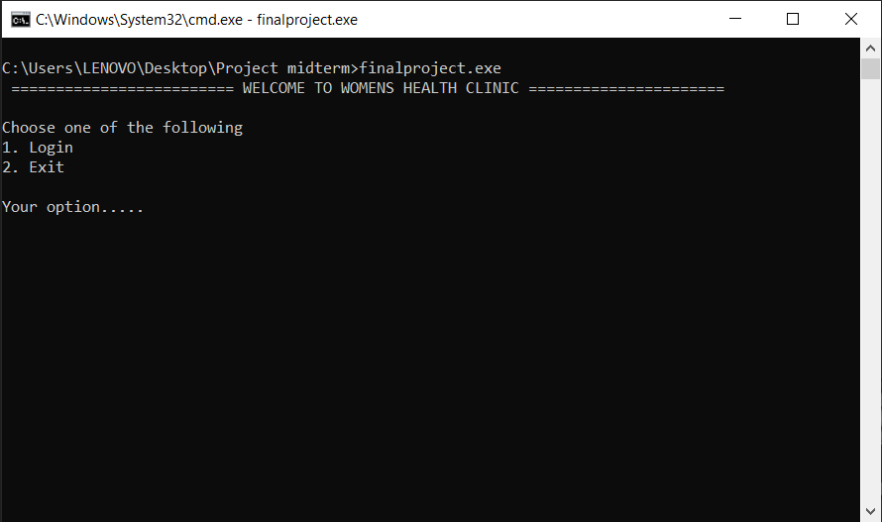

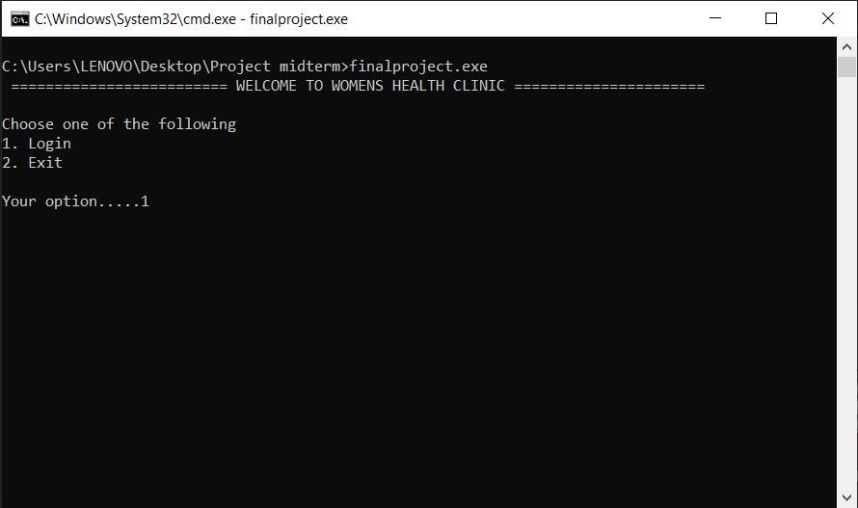

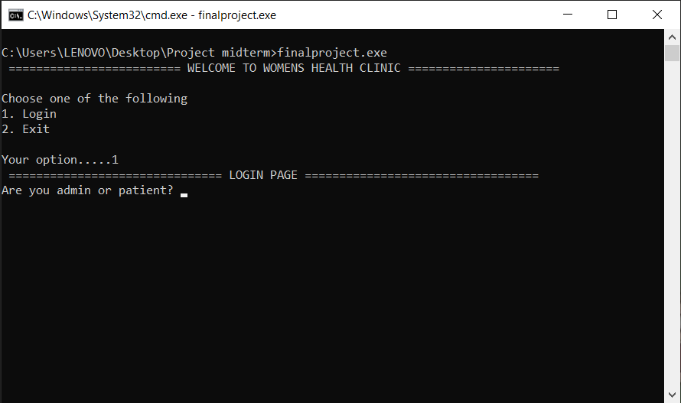

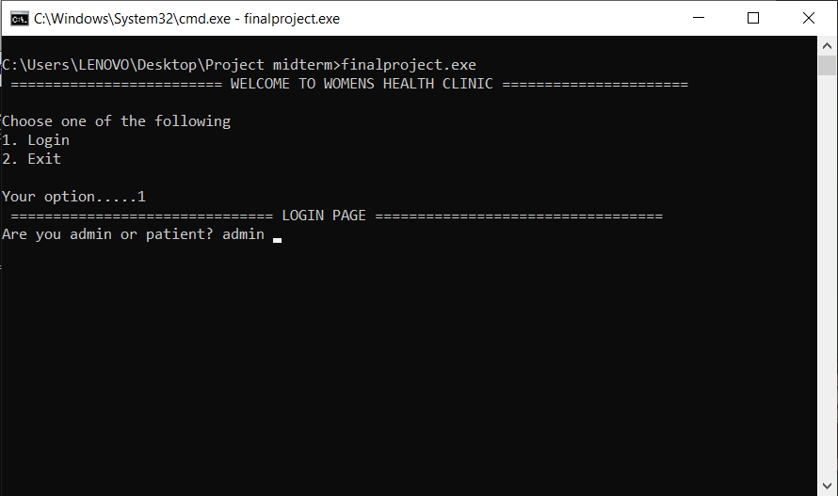

ADMIN’S ACCOUNT:-
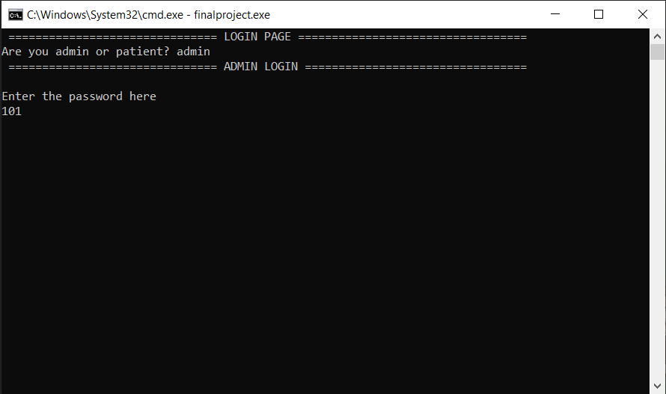

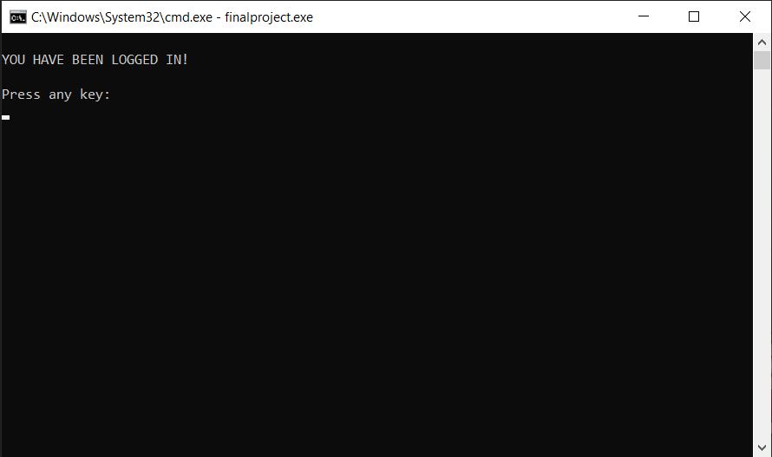

ADMIN’S MENU:
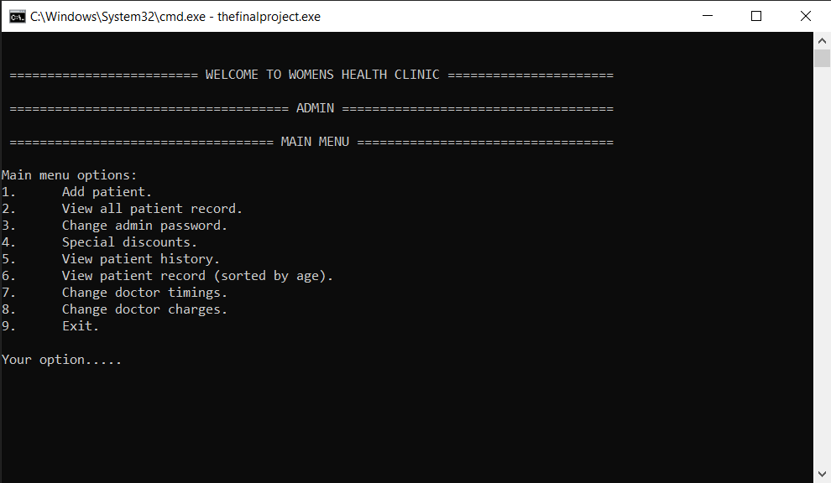

If chooses option 1:
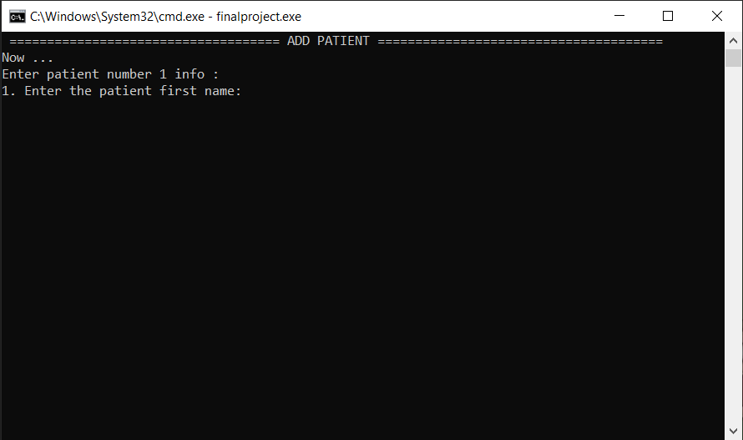

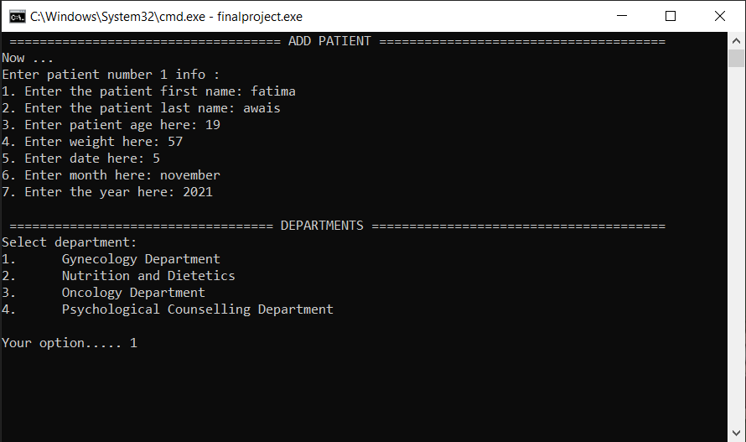

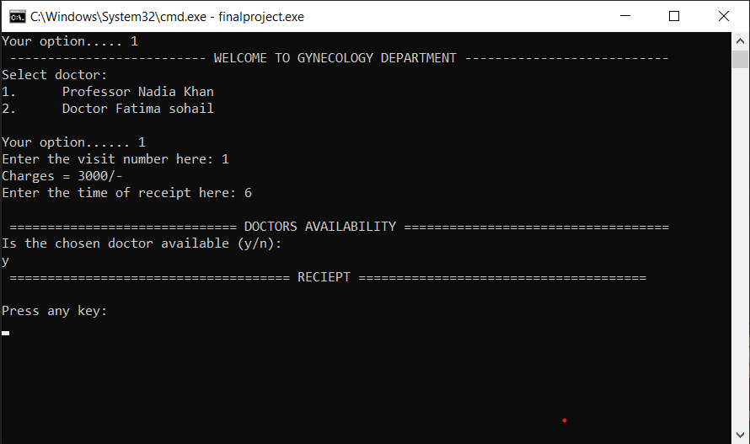

Receipt:
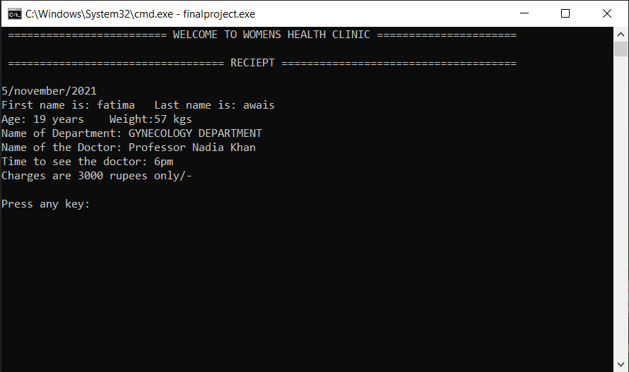
If chooses option 2:
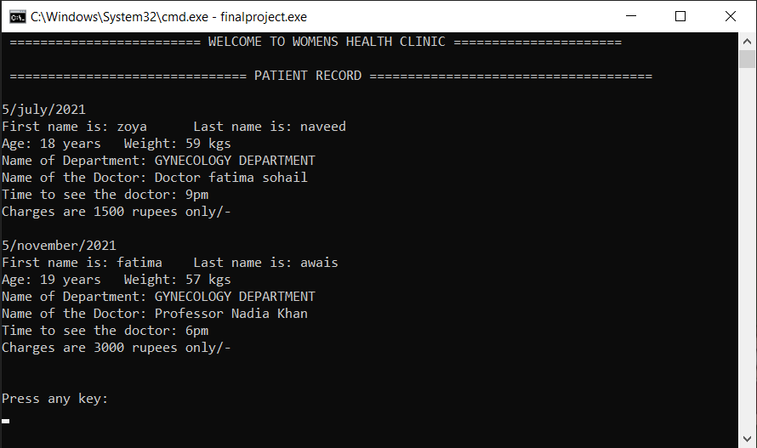

If chooses option 3:
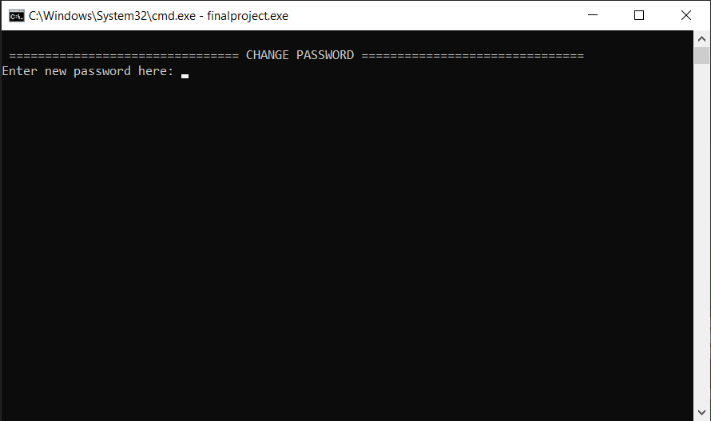
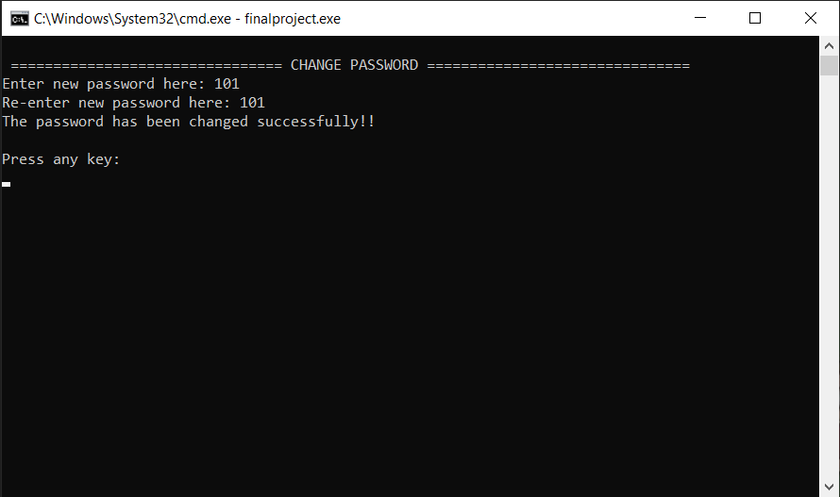

If chooses option 4:
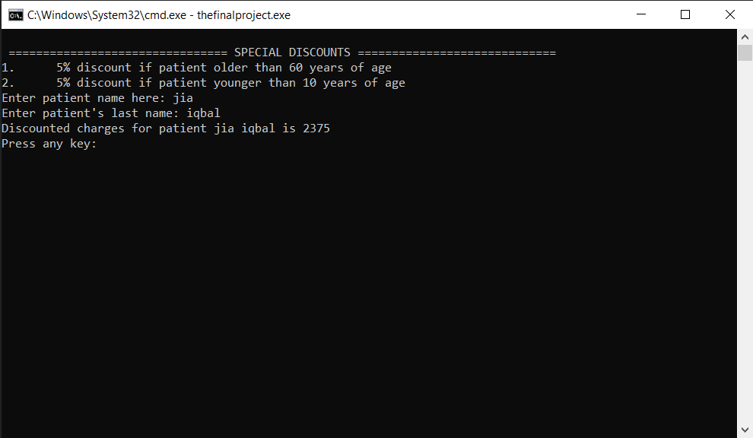
If chooses option 5:
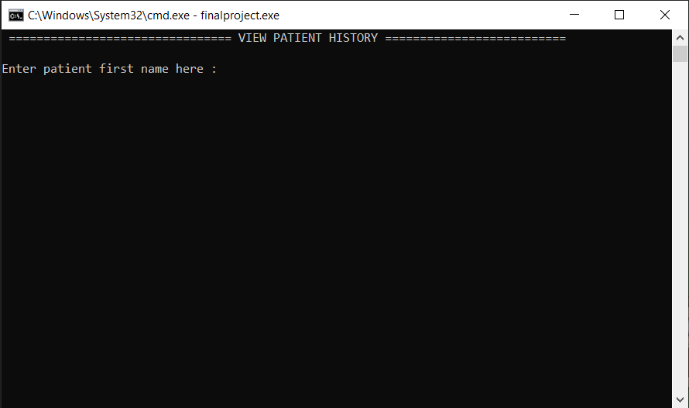

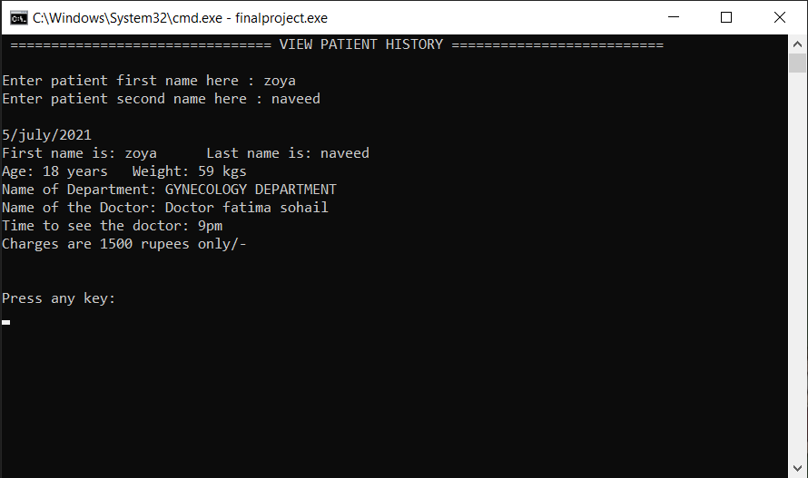
If chooses option 6:
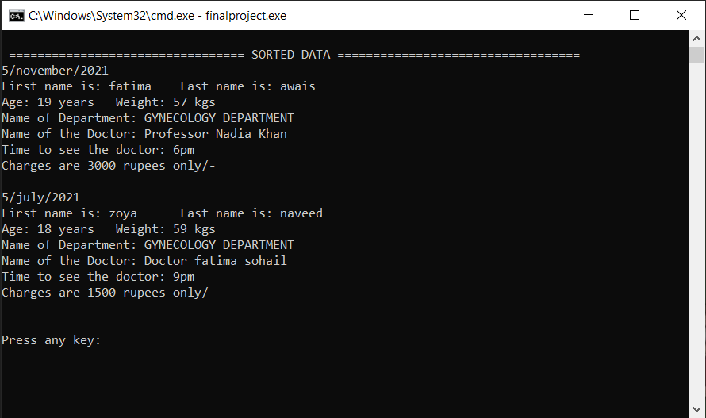
If chooses option 7: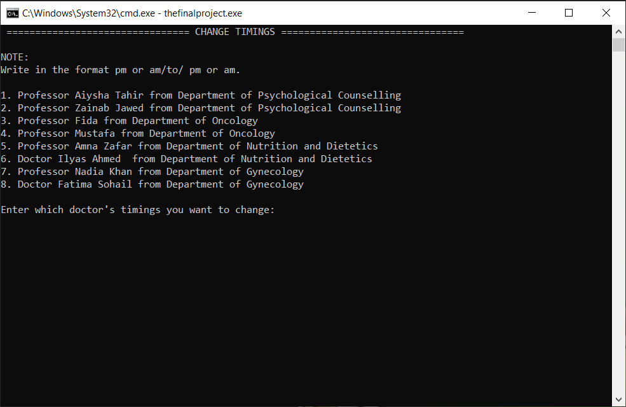
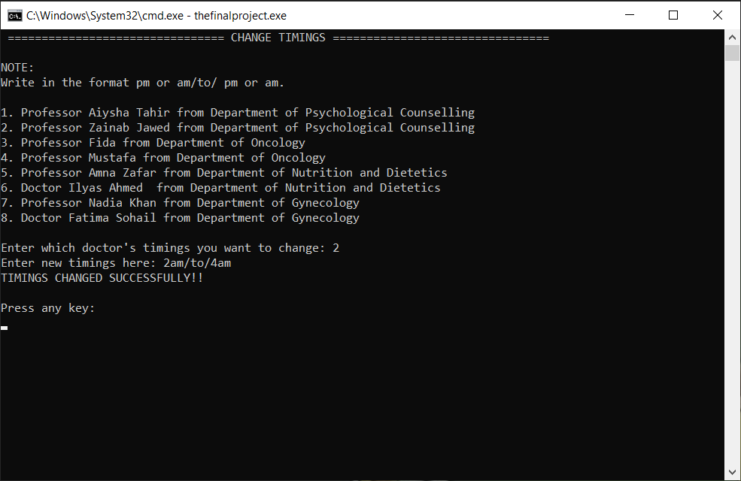
If chooses option 8: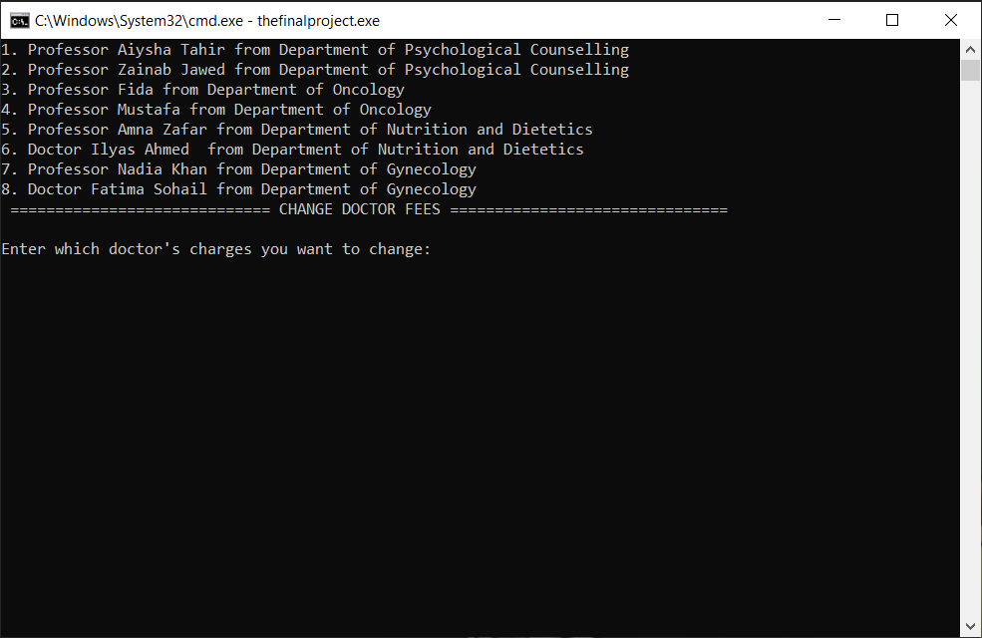
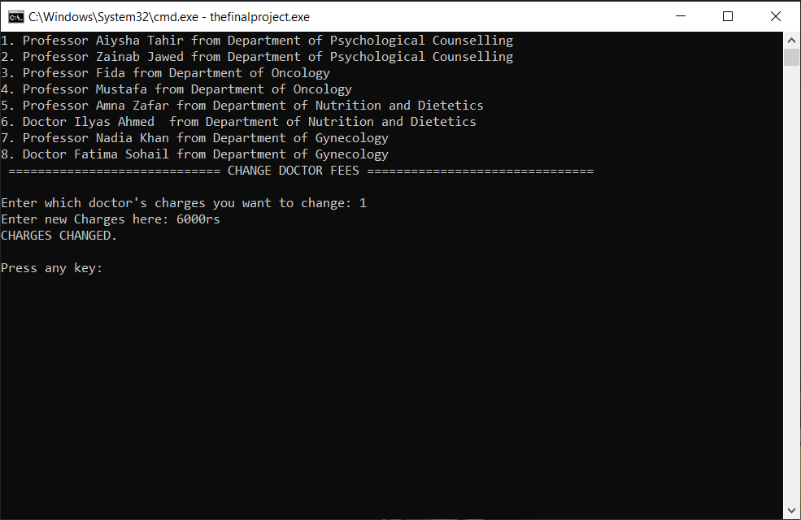

If chooses option 9:
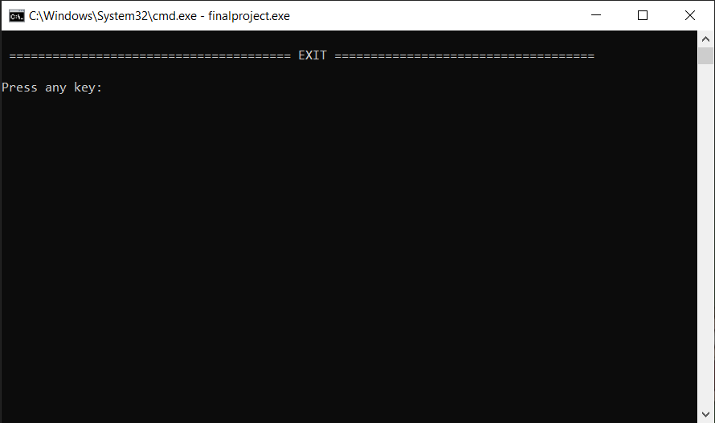
PATIENT’S LOGIN:-
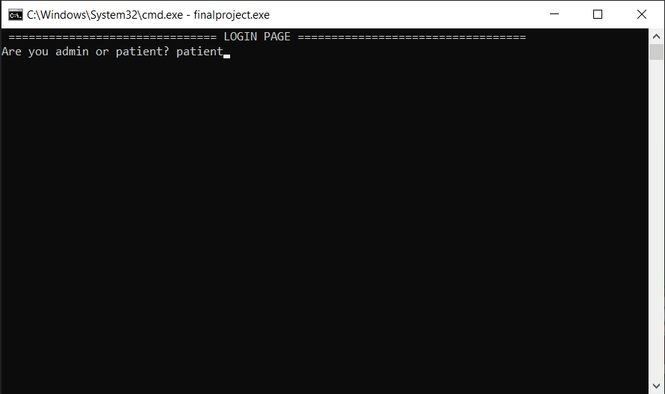

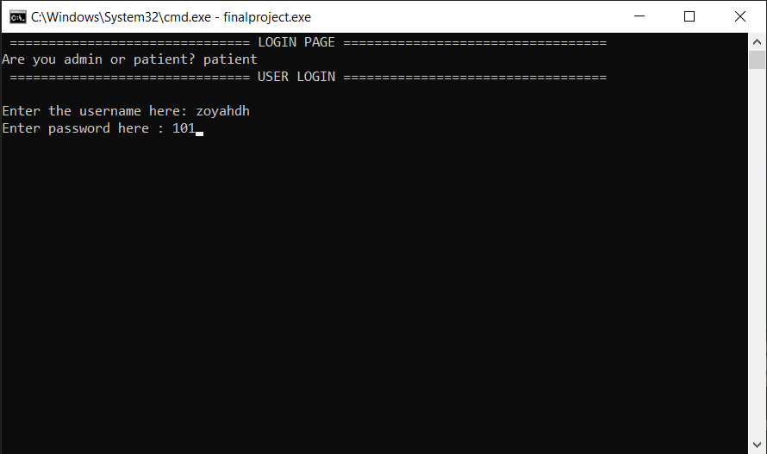

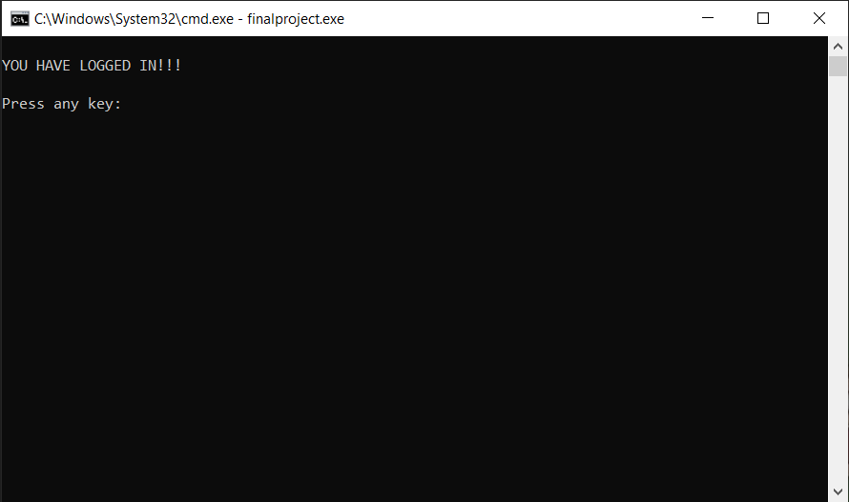
PATIENT’S MENU:
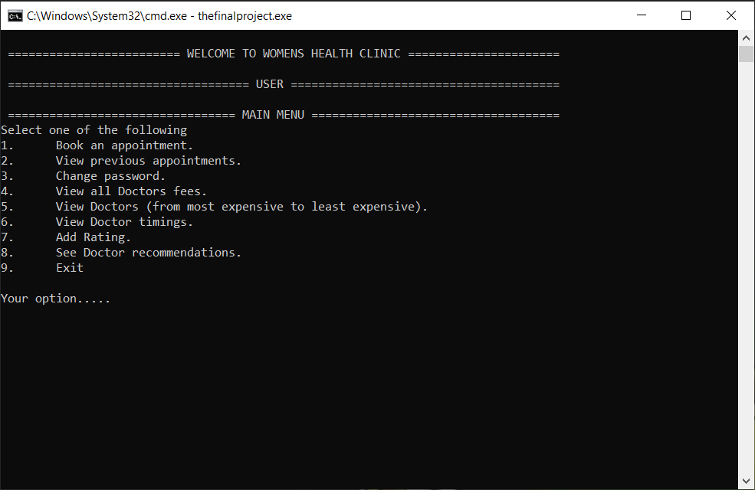
If chooses option 1:
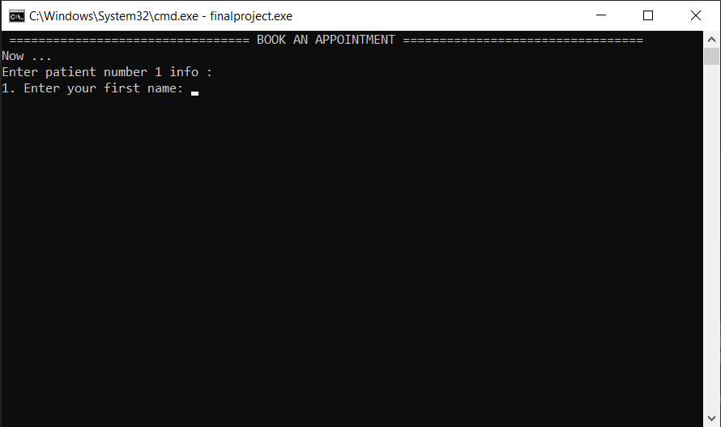

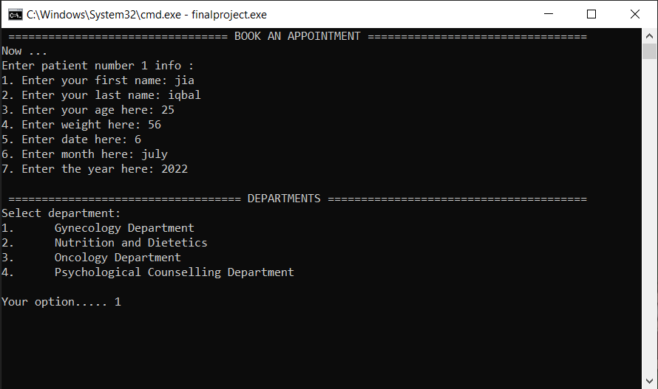

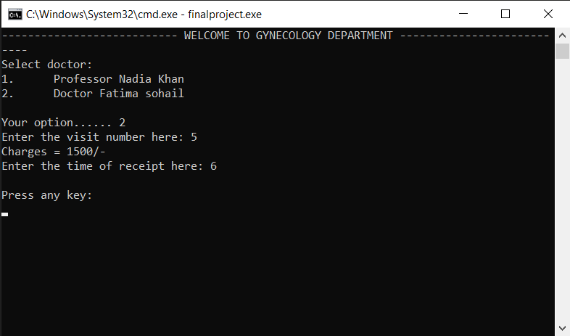

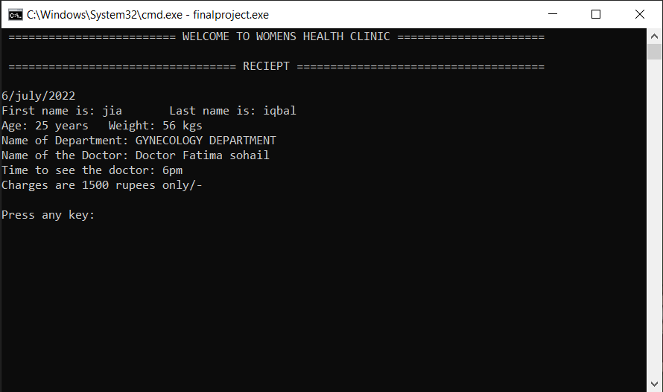

If chooses option 2:
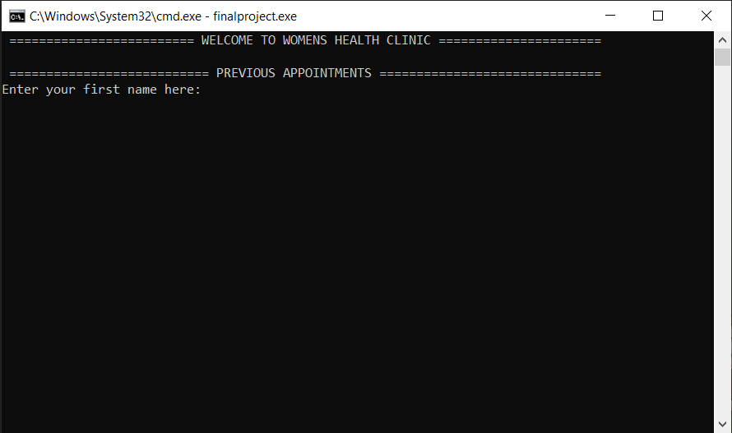

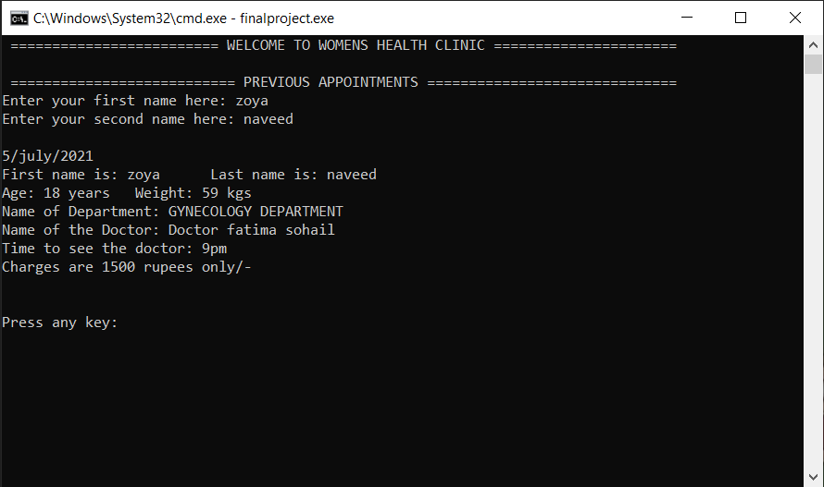

If chooses option 3: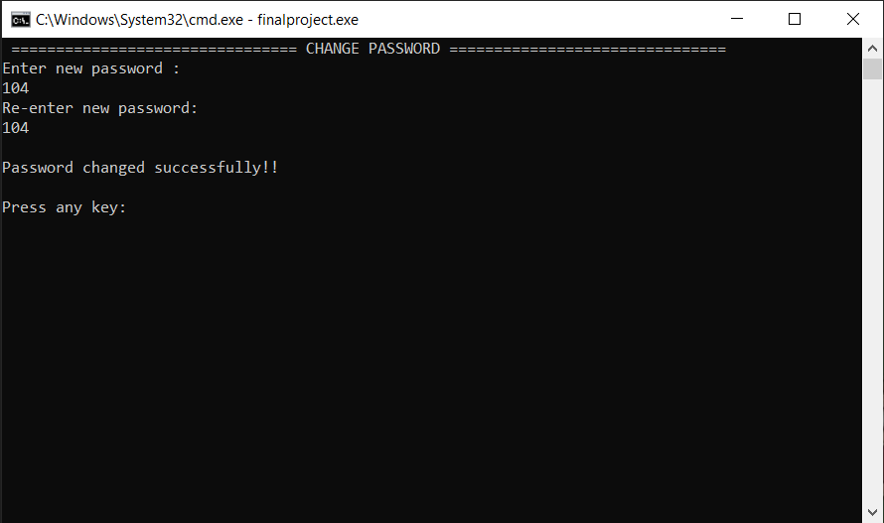
If chooses option 4:
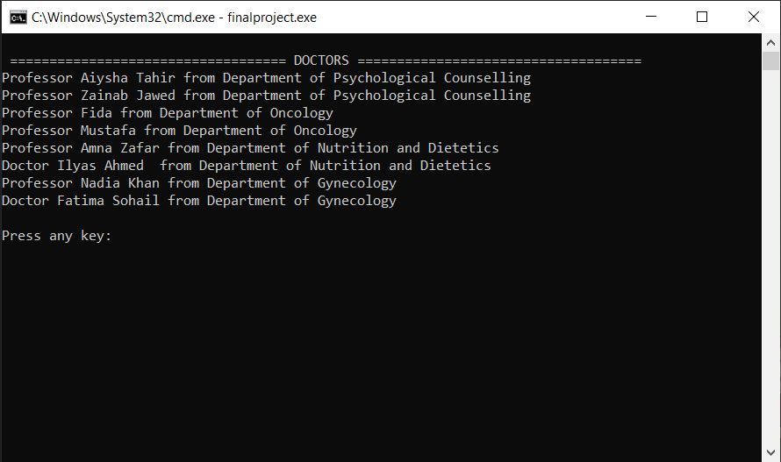
If chooses option 5: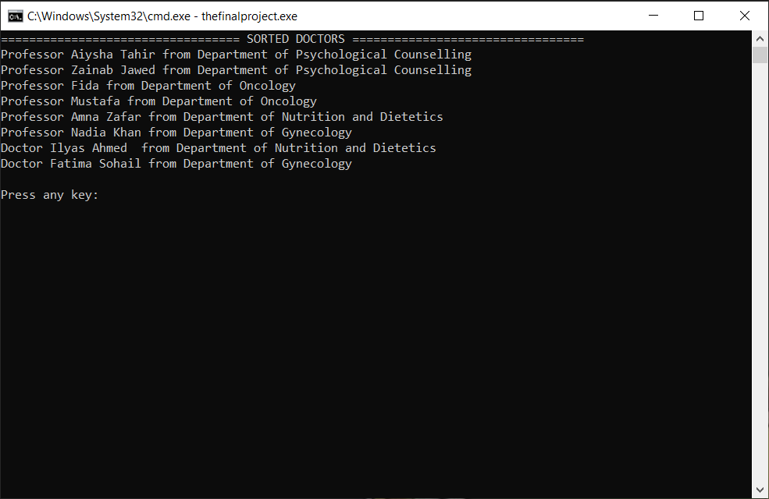
If chooses option 6: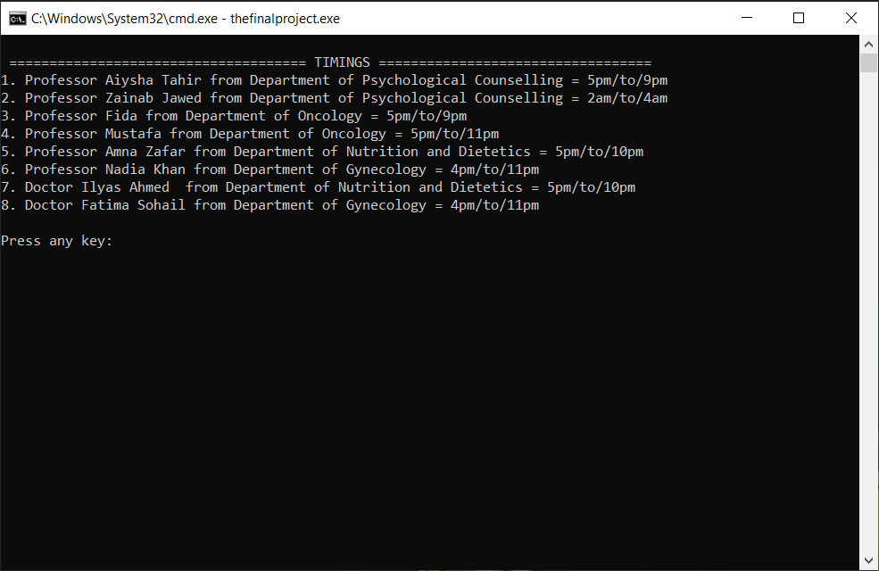
If chooses option 7: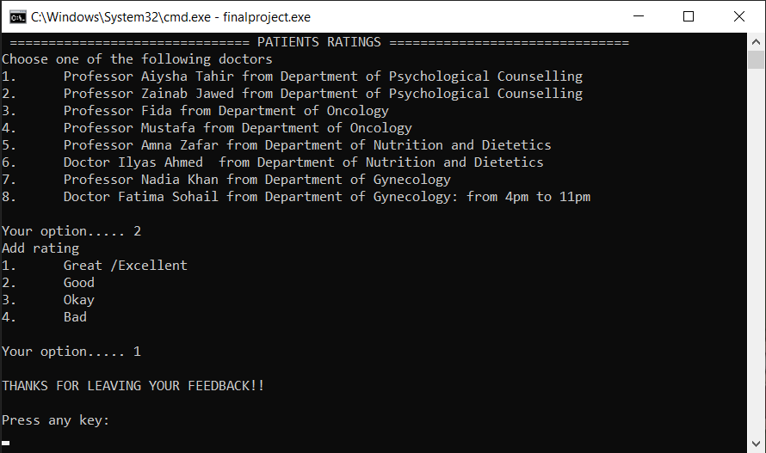
If chooses option 8:
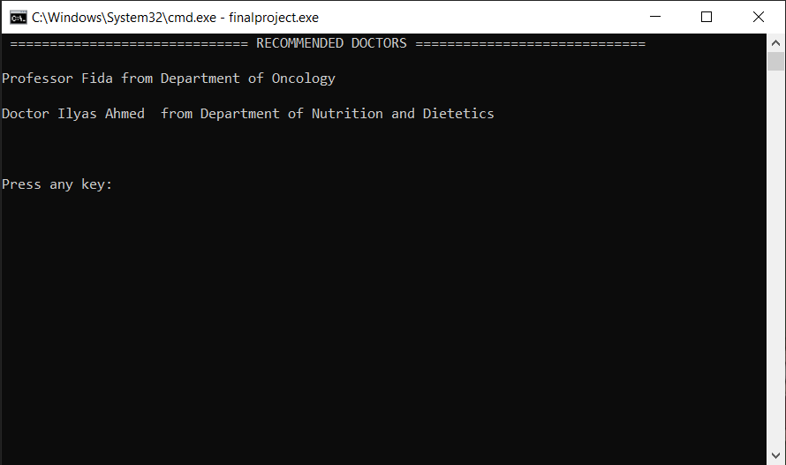

If chooses option 9:
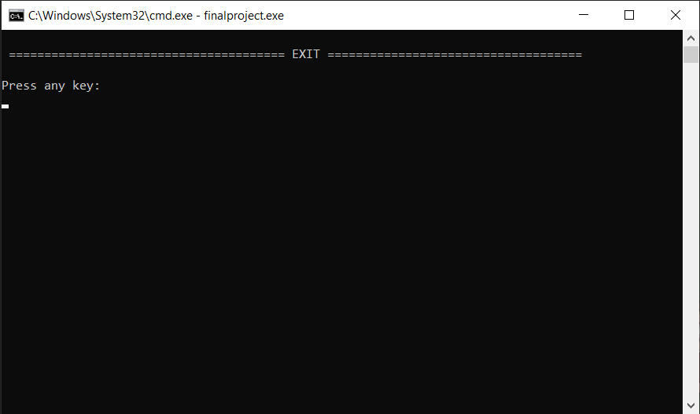
- Data structures
const int X = 100; // constant
//--------------ADMIN'S------------//
string patient_name1[X], patient_name2[X], month[X], department_name[X], doctor_name[X], doc_timings[X], doc_charges[X];
int age[X], weight[X], day[X], year[X], time[X], charges[X];
//------------PATIENT'S-----------//
string p_name[X], p_name2[X], p_month[X], p_department_name[X], p_doctor_name[X], doc_names[X], ch[X];
int p_age[X], p_weight[X], p_day[X], p_year[X], p_time[X], p_charges[X], rt_doc[X];

//--------------------------------------VARIABLES---------------------------//
int i = 0, j = 0, y = 0, c = 0, v = 0, b = 0, k = 0;
int mainchoice;
int a; // department selection variable
int opt1, opt2, opt3, opt4;
char availability, discount;
int num_of_visit;
string p_n1, p_n2, p_m;
int p_a, p_w, p_d, p_y, p_tm, fees, p_t;
string department, doc_n;
//-------------ADMIN'S------------//
string user, pass_of_admin_account, reenter_pass_of_admin_account, dis_name, dis_name2;
int option, count = 0, dis_charges, dis_cal;
string history1, history2, passA;
//-----------PATIENT'S-----------//
string patient_username, pass_of_patient_account, reenter_pass_of_patient_account;
int p_option, p_count = 0, choose_doc, d;
string check1, check2, passP, recs;

- Function prototypes
void mainHeader(); // mainHeader//admin + patient
void header(); // header//admin+patient
string login(); // login function//admin + patient
void exit(); // eXit option//admin + patient
void clearScreen(); // clear screen function//admin + patient
int departments(); // departments menu function // for admin + patient
void doc_info_from_file(); // loading doctors info and charges in arrays function//for option 4 , 6
void timings_from_file(); // loading doctor timings from file
void doc_charges_from_file(); // loading doctor charges from file
//-------------------ADMIN'S---------------//
int menu();
void pass_file(); // admin menu
void enterInfo(); // option 1//add a patient//enter information function
void addPatientInfoIntoArray(string p_n1, string p_n2, int p_a, int p_w, int p_d, string p_m, int p_y, string department, string doc_n, int fees, int p_t); // add a patient//add info into array function
void info_into_file(string p_n1, string p_n2, int p_a, int p_w, int p_d, string p_m, int p_y, string department, string doc_n, int fees, int p_t); // saving info in a file function
void load_data(); // loading patient info function
string parse(string data, int field); // comma separation function
void chosen_doctor();
void reciept(); // option 2 //patient reciept function
void change_pass(); // option 3 //change password function
void discounts(); // option 4//discounts function
void patientHistory(); // option 5//see patient history function
void sortPatient(); // option 6//sorting patient by age function
void change_timings(); // option 7//changing timings of doctors
void change_doc_charges(); // option 8//changing doctor charges

//---------------PATIENT'S-----------------//
int p_menu();
void pass_file_of_patient(); // patient's menu
void patient_info(); // option 1//store information entered function
void addPatientInfoIntoArray2(string p_n1, string p_n2, int p_a, int p_w, int p_d, string p_m, int p_y, string department, string doc_n, int fees, int p_t); // adding info entered into array function
void p_info_into_file(string p_n1, string p_n2, int p_a, int p_w, int p_d, string p_m, int p_y, string department, string doc_n, int fees, int p_t); // saving info into function
void p_load_data(); // load data in arrays function
void patient_reciept(); // option 2//patient reciept function
void patient_pass_change(); // option 3//password change function
void doctor_charges(); // option 4// viewing doctors and their charges
void sorted_doctors(); // option 5//doctor's most eXpensive to least eXpensive
void timings(); // option 6//doctor's timings
void feedback(); // option 7//patient feedback function
void recommendations();

- Function working flow

main

mainHeader()

Login()

admin
user
Doc_info_from_file()
Doc_info_from_file()
load_data()
P_load_data()
Doc_charges_from_file()
Pass_file_of_Patient()
pass_file()
Doc_charges_from_file()

Header()
Header()
Menu()

Reciept()
patientHistory()
Change_pass()
EnterInfo()
Discount()

sortPatient()

Change_doc_charges()
Change_timings()
Reciept()
Exit()
P_menu()

Patient_reciept()
Sorted_doctors()
Feedback()
Patient_pass
_change()
Exit()
Recommendations()
Timings()
Patient_info()
code
Doctors_charges()

COMPLETE CODE
#include <iostream>
#include <stdlib.h>
#include <conio.h>
#include <fstream>
using namespace std;

//------------------------------PROTYPES------------------------------------//
void mainHeader(); // mainHeader//admin + patient
void header(); // header//admin+patient
string login(); // login function//admin + patient
void exit(); // eXit option//admin + patient
void clearScreen(); // clear screen function//admin + patient
int departments(); // departments menu function // for admin + patient
void doc_info_from_file(); // loading doctors info and charges in arrays function//for option 4 , 6
void timings_from_file(); // loading doctor timings from file
void doc_charges_from_file(); // loading doctor charges from file
//-------------------ADMIN'S---------------//
int menu();
void pass_file(); // admin menu
void enterInfo(); // option 1//add a patient//enter information function
void addPatientInfoIntoArray(string p_n1, string p_n2, int p_a, int p_w, int p_d, string p_m, int p_y, string department, string doc_n, int fees, int p_t); // add a patient//add info into array function
void info_into_file(string p_n1, string p_n2, int p_a, int p_w, int p_d, string p_m, int p_y, string department, string doc_n, int fees, int p_t); // saving info in a file function
void load_data(); // loading patient info function
string parse(string data, int field); // comma separation function
void chosen_doctor();
void reciept(); // option 2 //patient reciept function
void change_pass(); // option 3 //change password function
void discounts(); // option 4//discounts function
void patientHistory(); // option 5//see patient history function
void sortPatient(); // option 6//sorting patient by age function
void change_timings(); // option 7//changing timings of doctors
void change_doc_charges(); // option 8//changing doctor charges

//---------------PATIENT'S-----------------//
int p_menu();
void pass_file_of_patient(); // patient's menu
void patient_info(); // option 1//store information entered function
void addPatientInfoIntoArray2(string p_n1, string p_n2, int p_a, int p_w, int p_d, string p_m, int p_y, string department, string doc_n, int fees, int p_t); // adding info entered into array function
void p_info_into_file(string p_n1, string p_n2, int p_a, int p_w, int p_d, string p_m, int p_y, string department, string doc_n, int fees, int p_t); // saving info into function
void p_load_data(); // load data in arrays function
void patient_reciept(); // option 2//patient reciept function
void patient_pass_change(); // option 3//password change function
void doctor_charges(); // option 4// viewing doctors and their charges
void sorted_doctors(); // option 5//doctor's most eXpensive to least eXpensive
void timings(); // option 6//doctor's timings
void feedback(); // option 7//patient feedback function
void recommendations(); // option 8//see recommendations function

//----------------------------------DATA STRUCTURES--------------------------//
const int X = 100; // constant
//--------------ADMIN'S------------//
string patient_name1[X], patient_name2[X], month[X], department_name[X], doctor_name[X], doc_timings[X], doc_charges[X];
int age[X], weight[X], day[X], year[X], time[X], charges[X];
//------------PATIENT'S-----------//
string p_name[X], p_name2[X], p_month[X], p_department_name[X], p_doctor_name[X], doc_names[X], ch[X];
int p_age[X], p_weight[X], p_day[X], p_year[X], p_time[X], p_charges[X], rt_doc[X];

//--------------------------------------VARIABLES---------------------------//
int i = 0, j = 0, y = 0, c = 0, v = 0, b = 0, k = 0;
int mainchoice;
int a; // department selection variable
int opt1, opt2, opt3, opt4;
char availability, discount;
int num_of_visit;
string p_n1, p_n2, p_m;
int p_a, p_w, p_d, p_y, p_tm, fees, p_t;
string department, doc_n;
//-------------ADMIN'S------------//
string user, pass_of_admin_account, reenter_pass_of_admin_account, dis_name, dis_name2;
int option, count = 0, dis_charges, dis_cal;
string history1, history2, passA;
//-----------PATIENT'S-----------//
string patient_username, pass_of_patient_account, reenter_pass_of_patient_account;
int p_option, p_count = 0, choose_doc, d;
string check1, check2, passP, recs;

main()
{
mainHeader();
while (true)
{
if (mainchoice == 1)
{
cout << " =============================== LOGIN PAGE ================================== " << endl;
user = login();
if (user == "admin")
{

cout << " =============================== ADMIN LOGIN ================================= " << endl;
cout << endl;
cout << "Enter the password here " << endl;
cin >> pass_of_admin_account;
pass_file();
system("cls");
if (pass_of_admin_account == passA)
{
cout << endl;
cout << "YOU HAVE BEEN LOGGED IN!" << endl;
option = 0;
clearScreen();
load_data();
doc_info_from_file();
doc_charges_from_file();
timings_from_file();
cout << endl;
while (option != 9)
{
cout << endl;
header();
cout << " ===================================== ADMIN ==================================== " << endl;
cout << endl;
option = menu();
if (option == 1)
{
system("cls");
enterInfo();
chosen_doctor();
if (availability == 'y')
{
clearScreen();
cout << " ================================== RECIEPT ===================================== " << endl;

// RECIEPT:-
header();
cout << endl;
cout << day[count] << "/" << month[count] << "/" << year[count] << endl;
cout << "First name is: " << patient_name1[count] << "\t"
<< "Last name is: " << patient_name2[count] << endl;
cout << "Age: " << age[count] << " years"
<< "\t "
<< "Weight:" << weight[count] << " kgs" << endl;
cout << "Name of Department: " << department_name[count] << endl;
cout << "Name of the Doctor: " << doctor_name[count] << endl;
cout << "Time to see the doctor: " << time[count] << "pm" << endl;
cout << "Charges are " << charges[count] << " rupees only/-" << endl;

count = count + 1;
clearScreen();
}
} // option 1
if (option == 2)
{
system("cls");
header();
cout << " =============================== PATIENT RECORD ===================================== " << endl;
cout << endl;
for (i = 0; i < X; i++)
{
if (charges[i] > 0)
{
reciept();
}
} // loop
clearScreen();
} // option 2
if (option == 3)
{
system("cls");
change_pass();
clearScreen();
} // option 3
if (option == 4)
{
system("cls");
discounts();
clearScreen();
} // option 4
if (option == 5)
{
system("cls");
patientHistory();
clearScreen();
} // option 5
if (option == 6)
{
system("cls");
sortPatient();
for (i = 0; i < X; i++)
{
if (charges[i] > 0)
{
reciept();
}
}
clearScreen();
} // option 6
if (option == 7)
{
system("cls");
change_timings();
clearScreen();
}
if (option == 8)
{
system("cls");
change_doc_charges();
clearScreen();
}
if (option == 9)
{
system("cls");
exit();
clearScreen();
}
} // while option is not 8
} // if admin pass is correct
else
{
cout << endl;
cout << "TRY AGAIN!!" << endl;
clearScreen();
} // if password is incorrect

} // user is admin
if (user == "patient")
{
cout << " ================== USER LOGIN =================== " << endl;
cout << " " << endl;
cout << "Enter the username here: ";
cin >> patient_username;
cout << "Enter password here : ";
cin >> pass_of_patient_account;
pass_file_of_patient();
system("cls");
if (patient_username == "zoyahdh" && pass_of_patient_account == passP)
{
cout << endl;
cout << "YOU HAVE LOGGED IN!!!" << endl;
clearScreen();
p_load_data();
doc_info_from_file();
timings_from_file();
doc_charges_from_file();
p_option = 0;
while (p_option != 9)
{
cout << endl;
header();
cout << " =================================== USER ======================================= " << endl;
cout << endl;
p_option = p_menu();
if (p_option == 1)
{
system("cls");
patient_info();
chosen_doctor();
if (availability == 'y')
{
clearScreen();
// RECIEPT:-
header();
cout << " ================================== RECIEPT ===================================== " << endl;

cout << endl;
cout << p_day[p_count] << "/" << p_month[p_count] << "/" << p_year[p_count] << endl;
cout << "First name is: " << p_name[p_count] << "\t"
<< " Last name is: " << p_name2[p_count] << endl;
cout << "Age: " << p_age[p_count] << " years"
<< "\t"
<< "Weight: " << p_weight[p_count] << " kgs" << endl;
cout << "Name of Department: " << p_department_name[p_count] << endl;
cout << "Name of the Doctor: " << p_doctor_name[p_count] << endl;
cout << "Time to see the doctor: " << p_time[p_count] << "pm" << endl;
cout << "Charges are " << p_charges[p_count] << " rupees only/-" << endl;

p_count = p_count + 1;
clearScreen();
}
else
{
system("cls");
cout << "Appointment not confirmed" << endl;
}
} // option 1

if (p_option == 2)
{
system("cls");
header();
cout << " =========================== PREVIOUS APPOINTMENTS ============================== " << endl;
cout << "Enter your first name here: ";
cin >> check1;
cout << "Enter your second name here: ";
cin >> check2;
for (i = 0; i < X; i++)
{
if (p_name[i] == check1 && p_name2[i] == check2)
{
patient_reciept();
}
}
clearScreen();
} // option 2
if (p_option == 3)
{
system("cls");
patient_pass_change();
clearScreen();
} // option is 3
if (p_option == 4)
{
system("cls");
doctor_charges();
clearScreen();
} // option is 4
if (p_option == 5)
{
system("cls");
sorted_doctors();
clearScreen();
} // option is 5
if (p_option == 6)
{
system("cls");
timings();
clearScreen();
} // option is 7
if (p_option == 7)
{
system("cls");
feedback();
clearScreen();
} // option is 7
if (p_option == 8)
{
system("cls");
recommendations();
clearScreen();
}

if (p_option == 9)
{
system("cls");
exit();
clearScreen();
}
} // while option is not 8
} // if password correct
else
{
cout << endl;
cout << "TRY AGAIN!!";
clearScreen();
}
} // user is patient
} // if mainchoice is login
else
{
exit();
break;
} // if mainchoice is eXit
} // while true//mainchoice
} // main

//-------------------------------------------------FUNCTIONS-------------------------------------//
void mainHeader()
{
cout << " ========================= WELCOME TO WOMENS HEALTH CLINIC ====================== " << endl;
cout << endl;
cout << "Choose one of the following" << endl;
cout << "1. Login" << endl;
cout << "2. Exit" << endl;
cout << endl;
cout << "Your option.....";
cin >> mainchoice;
}

void header()
{
cout << " ========================= WELCOME TO WOMENS HEALTH CLINIC ====================== " << endl;
cout << endl;
} // header

string login()
{
cout << "Are you admin or patient? ";
cin >> user;
return user;
} // login

void chosen_doctor()
{
cout << endl;
cout << " ============================== DOCTORS AVAILABILITY =================================== " << endl;
cout << "Confirm Doctor (y/n): " << endl;
cin >> availability;

} // chosen doctor function

int departments()
{
cout << endl;
cout << " =================================== DEPARTMENTS ======================================= " << endl;
cout << "Select department: " << endl;
cout << "1. Gynecology Department" << endl;
cout << "2. Nutrition and Dietetics" << endl;
cout << "3. Oncology Department" << endl;
cout << "4. Psychological Counselling Department" << endl;

cout << " " << endl;
cout << "Your option..... ";
cin >> a;
return a;
} // departments menu function // for admin + patient

void exit()
{
cout << endl;
cout << " ======================================= EXIT ==================================== " << endl;
} // function for exit

void clearScreen()
{
cout << endl;
char x;
cout << "Press any key: " << endl;
getch();
system("cls");
} // function of clear screen

void doc_charges_from_file()
{
fstream t;
t.open("doccharges.txt", ios::in);
int v = 0;
while (!t.eof())
{
getline(t, doc_charges[v]);
v++;
}
}

void doc_info_from_file()
{
fstream p;
p.open("docnames.txt", ios::in);
int v = 0;
while (!(p.eof()))
{
getline(p, doc_names[v]);
v++;
}
}

void timings_from_file()
{
fstream t;
t.open("doctimings.txt", ios::in);
int v = 0;
while (!t.eof())
{
getline(t, doc_timings[v]);
v++;
}
}
//----------------------------------------------ADMIN'S-----------------------------------------//

void pass_file()
{
fstream passfile;
passfile.open("passadmin.txt", ios::in);
passfile >> passA;
passfile.close();
}

int menu()
{
cout << " =================================== MAIN MENU ================================== " << endl;
cout << endl;
cout << "Main menu options:" << endl;
cout << "1. Add patient." << endl;
cout << "2. View all patient record." << endl;
cout << "3. Change admin password." << endl;
cout << "4. Special discounts." << endl;
cout << "5. View patient history." << endl;
cout << "6. View patient record (sorted by age)." << endl;
cout << "7. Change doctor timings. " << endl;
cout << "8. Change doctor charges. " << endl;
cout << "9. Exit. " << endl;
cout << endl;

cout << "Your option..... ";
cin >> option;
return option;
} // main menu function

void enterInfo()
{
system("cls");
cout << " ==================================== ADD PATIENT ====================================== ";
cout << endl;
cout << "Now ..." << endl;
cout << "Enter patient number 1 info : " << endl;
cout << "1. Enter the patient first name: ";
cin >> p_n1;
cout << "2. Enter the patient last name: ";
cin >> p_n2;
cout << "3. Enter patient age here: ";
cin >> p_a;
cout << "4. Enter weight here: ";
cin >> p_w;
cout << "5. Enter date here: ";
cin >> p_d;
cout << "6. Enter month here: ";
cin >> p_m;
cout << "7. Enter the year here: ";
cin >> p_y;
a = departments();
if (a == 1)
{
department = "GYNECOLOGY DEPARTMENT";
cout << " -------------------------- WELCOME TO GYNECOLOGY DEPARTMENT --------------------------- " << endl;
cout << "Select doctor: " << endl;
cout << "1. Professor Nadia Khan" << endl;
cout << "2. Doctor Fatima sohail" << endl;

cout << endl;
cout << "Your option...... ";
cin >> opt1;
if (opt1 == 1)
{
doc_n = "Professor Nadia Khan";
cout << "Enter the visit number here: ";
cin >> num_of_visit;
if (num_of_visit == 1)
{
cout << doc_charges[6];
fees = stoi(doc_charges[6]);
}
else
{
fees = stoi(doc_charges[6]) - 500;
cout << fees << endl;
}
}
if (opt1 == 2)
{
doc_n = "Doctor Fatima sohail";
cout << "Enter the visit number here: ";
cin >> num_of_visit;
if (num_of_visit == 1)
{
cout << doc_charges[7];
fees = stoi(doc_charges[7]);
}
else
{
fees = stoi(doc_charges[7]) - 500;
cout << fees << endl;
}
}
} // 1st
if (a == 2)
{
cout << " ------------------- WELCOME TO NUTRITION AND DIETETICS DEPARTMENT --------------------- " << endl;
cout << "Select doctor: " << endl;
cout << "1. Professor Amna Zafar" << endl;
cout << "2. Doctor Ilyas Ahmed " << endl;

cout << " " << endl;
cout << "Your option..... ";
cin >> opt2;
department = "NUTRITION AND DIETETICS";
if (opt2 == 1)
{
doc_n = "Professor Amna Zafar";
cout << "Enter the visit number here: ";
cin >> num_of_visit;
if (num_of_visit == 1)
{
cout << doc_charges[4];
fees = stoi(doc_charges[4]);
}
else
{
fees = stoi(doc_charges[4]) - 500;
cout << fees << endl;
}
}
if (opt2 == 2)
{
doc_n = "Doctor Ilyas Ahmed";
cout << "Enter the visit number here: ";
cin >> num_of_visit;
if (num_of_visit == 1)
{
cout << doc_charges[5];
fees = stoi(doc_charges[5]);
}
else
{
fees = stoi(doc_charges[5]) - 500;
cout << fees << endl;
}
}
} // 2nd
if (a == 3)
{
cout << " ---------------------------- WELCOME TO ONCOLOGY DEPARTMENT --------------------------- " << endl;
cout << "Select doctor: " << endl;
cout << "1. Professor Mustafa for diagnosis" << endl;
cout << "2. Professor Fida for ultrasound" << endl;

cout << " " << endl;
cout << "Your option..... ";
cin >> opt3;
department = "ONCOLOGY DEPARTMENT";
if (opt3 == 1)
{
doc_n = "Professor Mustafa for diagnosis";
cout << "Special discount for breast cancer awareness month (y/n): ";
cin >> discount;
if (discount == 'y')
{
fees = stoi(doc_charges[3]) - 200;
cout << fees;
}
else
{
cout << doc_charges[3];
fees = stoi(doc_charges[3]);
}
}
if (opt3 == 2)
{
doc_n = "Professor Fida for ultrasound";

cout << "Special discount for breast cancer awareness month (y/n): ";
cin >> discount;

if (discount == 'y')
{
fees = stoi(doc_charges[2]) - 200;
cout << fees;
}
else
{
cout << doc_charges[2];
fees = stoi(doc_charges[2]);
}
}
} // 3rd
if (a == 4)
{
cout << "------------------- WELCOME TO DEPARTMENT OF PSYCOLOGICAL COUNSELLING ------------------ " << endl;
cout << "Select doctor: " << endl;
cout << "1. Professor Aiysha Tahir" << endl;
cout << "2. Professor Zainab Jawed " << endl;

cout << " " << endl;
cout << "Your option..... ";
cin >> opt4;
department = "PSYCOLOGICAL COUNSELLING DEPARTMENT";
if (opt4 == 1)
{
doc_n = "Professor Aiysha Tahir";
cout << "Enter the visit number here: ";
cin >> num_of_visit;
if (num_of_visit == 1)
{
cout << doc_charges[0];
fees = stoi(doc_charges[0]);
}
else
{
fees = stoi(doc_charges[0]) - 500;
cout << fees << endl;
}
}
if (opt4 == 2)
{
doc_n = "Professor Zainab Jawed";
cout << "Enter the visit number here: ";
cin >> num_of_visit;
if (num_of_visit == 1)
{
cout << doc_charges[1];
fees = stoi(doc_charges[1]);
}
else
{
fees = stoi(doc_charges[1]) - 500;
cout << fees << endl;
}
}
} // 4th
cout << endl;
cout << "Enter the time of receipt here: ";
cin >> p_t;
addPatientInfoIntoArray(p_n1, p_n2, p_a, p_w, p_d, p_m, p_y, department, doc_n, fees, p_t);
info_into_file(p_n1, p_n2, p_a, p_w, p_d, p_m, p_y, department, doc_n, fees, p_t);
}

void addPatientInfoIntoArray(string p_n1, string p_n2, int p_a, int p_w, int p_d, string p_m, int p_y, string department, string doc_n, int fees, int p_t)
{
patient_name1[count] = p_n1;
patient_name2[count] = p_n2;
age[count] = p_a;
weight[count] = p_w;
day[count] = p_d;
month[count] = p_m;
year[count] = p_y;
department_name[count] = department;
doctor_name[count] = doc_n;
charges[count] = fees;
time[count] = p_t;
} // option 1 : Enter student info

void info_into_file(string p_n1, string p_n2, int p_a, int p_w, int p_d, string p_m, int p_y, string department, string doc_n, int fees, int p_t)
{
fstream file;
file.open("projectadmin.txt", ios::app);
file << '\n' + p_n1 + "," + p_n2 + "," + to_string(p_a) + "," + to_string(p_w) + "," + to_string(p_d) + "," + p_m + "," + to_string(p_y) + "," + department + "," + doc_n + "," + to_string(fees) + "," + to_string(p_t) + ",";
file.close();
}
void load_data()
{
string data;
int z = 0;
fstream newfile;
newfile.open("projectadmin.txt", ios::in);
while (!(newfile.eof()))
{
getline(newfile, data);
patient_name1[z] = parse(data, 1);
patient_name2[z] = parse(data, 2);
age[z] = stoi(parse(data, 3));
weight[z] = stoi(parse(data, 4));
day[z] = stoi(parse(data, 5));
month[z] = parse(data, 6);
year[z] = stoi(parse(data, 7));
department_name[z] = parse(data, 8);
doctor_name[z] = parse(data, 9);
charges[z] = stoi(parse(data, 10));
time[z] = stoi(parse(data, 11));
z = z + 1;
}
newfile.close();
}
string parse(string data, int field)
{
int commacount = 1;
string item;
for (int y = 0; y < 100; y++)
{
if (data[y] == ',')
{
commacount = commacount + 1;
}
else if (commacount == field)
{
item = item + data[y];
}
}
return item;
}

void reciept()
{
cout << day[i] << "/" << month[i] << "/" << year[i] << endl;
cout << "First name is: " << patient_name1[i] << "\t"
<< " Last name is: " << patient_name2[i] << endl;
cout << "Age: " << age[i] << " years"
<< "\t"
<< "Weight: " << weight[i] << " kgs" << endl;
cout << "Name of Department: " << department_name[i] << endl;
cout << "Name of the Doctor: " << doctor_name[i] << endl;
cout << "Time to see the doctor: " << time[i] << "pm" << endl;
cout << "Charges are " << charges[i] << " rupees only/-" << endl;
cout << endl;
} // function of option 2 and display

void change_pass()
{
system("cls");
cout << " " << endl;
cout << " ================== CHANGE PASSWORD =============== " << endl;
cout << "Enter new password here: ";
cin >> pass_of_admin_account;
cout << "Re-enter new password here: ";
cin >> reenter_pass_of_admin_account;
if (pass_of_admin_account == reenter_pass_of_admin_account)
{
fstream fload;
fload.open("passadmin.txt", ios::out);
fload << pass_of_admin_account;
cout << "The password has been changed successfully!!" << endl;
}
else
{
cout << "Password not changed";
}
} // function of option 3

void discounts()
{
system("cls");
cout << endl;
cout << " ================================ SPECIAL DISCOUNTS ============================= " << endl;
cout << "1. 5% discount if patient older than 60 years of age" << endl;
cout << "2. 5% discount if patient younger than 10 years of age" << endl;

cout << "Enter patient name here: ";
cin >> dis_name;
cout << "Enter patient's last name: ";
cin >> dis_name2;

for (int h = 0; h < X; h++)
{
if (patient_name1[h] == dis_name && patient_name2[h] == dis_name2)
{
dis_charges = charges[h];

if (age[h] >= 60)
{
dis_cal = ((dis_charges / 100) * 5);
dis_charges = dis_charges - dis_cal;
charges[h] = dis_charges;
}
if (age[h] < 10)
{
dis_cal = ((dis_charges / 100) * 5);
dis_charges = dis_charges - dis_cal;
charges[h] = dis_charges;
}
cout << "Discounted charges for patient " << patient_name1[h] << " " << patient_name2[h] << " is " << charges[h];
}
}
} // function for option 4

void patientHistory()
{
cout << " ================================ VIEW PATIENT HISTORY ========================== " << endl;
cout << endl;
cout << "Enter patient first name here : ";
cin >> history1;
cout << "Enter patient second name here : ";
cin >> history2;
for (i = 0; i < X; i++)
{
if (history1 == patient_name1[i] && history2 == patient_name2[i])
{
cout << endl;
reciept();
}
}
} // function of option 5

void sortPatient()
{
cout << endl;
cout << " ================================= SORTED DATA ================================== " << endl;
int a_temp, w_temp, d_temp, y_temp, time_temp, char_temp;
string p_1_temp, p_2_temp, dep_temp, doc_temp, m_temp;
for (i = 0; i < X; i++)
{
for (j = i + 1; j <= X - 1; j++)
{
if (age[j] > age[i])
{
a_temp = age[j];
age[j] = age[i];
age[i] = a_temp;

p_1_temp = patient_name1[j];
patient_name1[j] = patient_name1[i];
patient_name1[i] = p_1_temp;

p_2_temp = patient_name2[j];
patient_name2[j] = patient_name2[i];
patient_name2[i] = p_2_temp;

w_temp = weight[j];
weight[j] = weight[i];
weight[i] = w_temp;

dep_temp = department_name[j];
department_name[j] = department_name[i];
department_name[i] = dep_temp;

doc_temp = doctor_name[j];
doctor_name[j] = doctor_name[i];
doctor_name[i] = doc_temp;

d_temp = day[j];
day[j] = day[i];
day[i] = d_temp;

m_temp = month[j];
month[j] = month[i];
month[i] = m_temp;

y_temp = year[j];
year[j] = year[i];
year[i] = y_temp;

time_temp = time[j];
time[j] = time[i];
time[i] = time_temp;

char_temp = charges[j];
charges[j] = charges[i];
charges[i] = char_temp;
}
}
}
} // function of option 6

void change_timings()
{
int k;
string e;
cout << " ================================ CHANGE TIMINGS ================================ " << endl;
cout << endl;
cout << "NOTE: " << endl;
cout << "Write in the format pm or am/to/ pm or am." << endl;
cout << endl;
for (int u = 0; u < 8; u++)
{
cout << u + 1 << ". " << doc_names[u] << endl;
}
cout << endl;
cout << "Enter which doctor's timings you want to change: ";
cin >> k;
cout << "Enter new timings here: ";
cin >> doc_timings[k - 1];
fstream w;
w.open("doctimings.txt", ios::out);
for (int u = 0; u < 8; u++)
{
w << doc_timings[u] << endl;
}
cout << "TIMINGS CHANGED SUCCESSFULLY!!" << endl;
}

void change_doc_charges()
{
for (int u = 0; u < 8; u++)
{
cout << u + 1 << ". " << doc_names[u] << endl;
}
cout << " ============================= CHANGE DOCTOR FEES =============================== " << endl;
cout << endl;
cout << "Enter which doctor's charges you want to change: ";
cin >> k;
cout << "Enter new Charges here: ";
cin >> doc_charges[k - 1];
fstream w;
w.open("doccharges.txt", ios::out);
for (int u = 0; u < 8; u++)
{
w << doc_charges[u] << endl;
}
cout << "CHARGES CHANGED." << endl;
}
//--------------------------------------------PATIENT'S------------------------------------------//

int p_menu()
{
cout << " ================================= MAIN MENU ==================================== " << endl;
cout << "Select one of the following" << endl;
cout << "1. Book an appointment." << endl;
cout << "2. View previous appointments." << endl;
cout << "3. Change password." << endl;
cout << "4. View all Doctors fees." << endl;
cout << "5. View Doctors (from most expensive to least expensive)." << endl;
cout << "6. View Doctor timings." << endl;
cout << "7. Add Rating." << endl;
cout << "8. See Doctor recommendations." << endl;
cout << "9. Exit" << endl;

cout << endl;
cout << "Your option.....";
cin >> p_option;
return p_option;
}

void pass_file_of_patient()
{
fstream passfile;
passfile.open("passuser.txt", ios::in);
passfile >> passP;
passfile.close();
}

void patient_info()
{
system("cls");
cout << " ================================= BOOK AN APPOINTMENT ================================= ";
cout << endl;
cout << "Now ..." << endl;
cout << "Enter patient number 1 info : " << endl;
cout << "1. Enter your first name: ";
cin >> p_n1;
cout << "2. Enter your last name: ";
cin >> p_n2;
cout << "3. Enter your age here: ";
cin >> p_a;
cout << "4. Enter weight here: ";
cin >> p_w;
cout << "5. Enter date here: ";
cin >> p_d;
cout << "6. Enter month here: ";
cin >> p_m;
cout << "7. Enter the year here: ";
cin >> p_y;
a = departments();
if (a == 1)
{
department = "GYNECOLOGY DEPARTMENT";
cout << "--------------------------- WELCOME TO GYNECOLOGY DEPARTMENT --------------------------- " << endl;
cout << "Select doctor: " << endl;
cout << "1. Professor Nadia Khan" << endl;
cout << "2. Doctor Fatima sohail" << endl;

cout << endl;
cout << "Your option...... ";
cin >> opt1;
if (opt1 == 1)
{
doc_n = "Professor Nadia Khan";
cout << "Enter the visit number here: ";
cin >> num_of_visit;
if (num_of_visit == 1)
{
cout << doc_charges[6];
fees = stoi(doc_charges[6]);
}
else
{
fees = stoi(doc_charges[6]) - 500;
cout << fees << endl;
}
}
if (opt1 == 2)
{
doc_n = "Doctor Fatima sohail";
cout << "Enter the visit number here: ";
cin >> num_of_visit;
if (num_of_visit == 1)
{
cout << doc_charges[7];
fees = stoi(doc_charges[7]);
}
else
{
fees = stoi(doc_charges[7]) - 500;
cout << fees << endl;
}
}
} // 1st
if (a == 2)
{
cout << "---------------------- WELCOME TO NUTRITION AND DIETETICS DEPARTMENT ------------------- " << endl;
cout << "Select doctor: " << endl;
cout << "1. Professor Amna Zafar" << endl;
cout << "2. Doctor Ilyas Ahmed " << endl;

cout << " " << endl;
cout << "Your option..... ";
cin >> opt2;
department = "NUTRITION AND DIETETICS";
if (opt2 == 1)
{
doc_n = "Professor Amna Zafar";
cout << "Enter the visit number here: ";
cin >> num_of_visit;
if (num_of_visit == 1)
{
cout << doc_charges[4];
fees = stoi(doc_charges[4]);
}
else
{
fees = stoi(doc_charges[4]) - 500;
cout << fees << endl;
}
}
if (opt2 == 2)
{
doc_n = "Doctor Ilyas Ahmed";
cout << "Enter the visit number here: ";
cin >> num_of_visit;
if (num_of_visit == 1)
{
cout << doc_charges[5];
fees = stoi(doc_charges[5]);
}
else
{
fees = stoi(doc_charges[5]) - 500;
cout << fees << endl;
}
}
} // 2nd
if (a == 3)
{
cout << "---------------------------- WELCOME TO ONCOLOGY DEPARTMENT ---------------------------- " << endl;
cout << "Select doctor: " << endl;
cout << "1. Professor Mustafa for diagnosis" << endl;
cout << "2. Professor Fida for ultrasound" << endl;

cout << " " << endl;
cout << "Your option..... ";
cin >> opt3;
department = "ONCOLOGY DEPARTMENT";
if (opt3 == 1)
{
doc_n = "Professor Mustafa for diagnosis";
cout << "Special discount for breast cancer awareness month (y/n): ";
cin >> discount;
if (discount == 'y')
{
fees = stoi(doc_charges[3]) - 200;
cout << fees;
}
else
{
fees = stoi(doc_charges[3]) - 200;
cout << fees;
}
}
if (opt3 == 2)
{
doc_n = "Professor Fida for ultrasound";

cout << "Special discount for breast cancer awareness month (y/n): ";
cin >> discount;

if (discount == 'y')
{
fees = stoi(doc_charges[2]) - 200;
cout << fees;
}
else
{
fees = stoi(doc_charges[2]) - 200;
cout << fees;
}
}
} // 3rd
if (a == 4)
{
cout << "-------------------- WELCOME TO DEPARTMENT OF PSYCOLOGICAL COUNSELLING------------------ " << endl;
cout << "Select doctor: " << endl;
cout << "1. Professor Aiysha Tahir" << endl;
cout << "2. Professor Zainab Jawed " << endl;

cout << " " << endl;
cout << "Your option..... ";
cin >> opt4;
department = "PSYCOLOGICAL COUNSELLING DEPARTMENT";
if (opt4 == 1)
{
doc_n = "Professor Aiysha Tahir";
cout << "Enter the visit number here: ";
cin >> num_of_visit;
if (num_of_visit == 1)
{
cout << doc_charges[0];
fees = stoi(doc_charges[0]);
}
else
{
fees = stoi(doc_charges[0]) - 500;
cout << fees << endl;
}
}
if (opt4 == 2)
{
doc_n = "Professor Zainab Jawed";
cout << "Enter the visit number here: ";
cin >> num_of_visit;
if (num_of_visit == 1)
{
cout << doc_charges[1];
fees = stoi(doc_charges[1]);
}
else
{
fees = stoi(doc_charges[1]) - 500;
cout << fees << endl;
}
}
} // 4th
cout << endl;

cout << "Enter the time of receipt here: ";
cin >> p_t;

addPatientInfoIntoArray2(p_n1, p_n2, p_a, p_w, p_d, p_m, p_y, department, doc_n, fees, p_t);
p_info_into_file(p_n1, p_n2, p_a, p_w, p_d, p_m, p_y, department, doc_n, fees, p_t);
}

void addPatientInfoIntoArray2(string p_n1, string p_n2, int p_a, int p_w, int p_d, string p_m, int p_y, string department, string doc_n, int fees, int p_t)
{
p_name[p_count] = p_n1;
p_name2[p_count] = p_n2;
p_age[p_count] = p_a;
p_weight[p_count] = p_w;
p_day[p_count] = p_d;
p_month[p_count] = p_m;
p_year[p_count] = p_y;
p_department_name[p_count] = department;
p_doctor_name[p_count] = doc_n;
p_time[p_count] = p_t;
p_charges[p_count] = fees;
}

void p_info_into_file(string p_n1, string p_n2, int p_a, int p_w, int p_d, string p_m, int p_y, string department, string doc_n, int fees, int p_t)
{
fstream pfile;
pfile.open("projectuser.txt", ios::app);
pfile << '\n' + p_n1 + "," + p_n2 + "," + to_string(p_a) + "," + to_string(p_w) + "," + to_string(p_d) + "," + p_m + "," + to_string(p_y) + "," + department + "," + doc_n + "," + to_string(fees) + "," + to_string(p_t) + ",";
pfile.close();
}
void p_load_data()
{
string pdata;
int z = 0;
fstream newPfile;
newPfile.open("projectuser.txt", ios::in);
while (!(newPfile.eof()))
{
getline(newPfile, pdata);
p_name[z] = parse(pdata, 1);
p_name2[z] = parse(pdata, 2);
p_age[z] = stoi(parse(pdata, 3));
p_weight[z] = stoi(parse(pdata, 4));
p_day[z] = stoi(parse(pdata, 5));
p_month[z] = parse(pdata, 6);
p_year[z] = stoi(parse(pdata, 7));
p_department_name[z] = parse(pdata, 8);
p_doctor_name[z] = parse(pdata, 9);
p_charges[z] = stoi(parse(pdata, 10));
p_time[z] = stoi(parse(pdata, 11));
z = z + 1;
}
newPfile.close();
}

void patient_reciept()
{
cout << endl;
cout << p_day[i] << "/" << p_month[i] << "/" << p_year[i] << endl;
cout << "First name is: " << p_name[i] << "\t"
<< " Last name is: " << p_name2[i] << endl;
cout << "Age: " << p_age[i] << " years"
<< "\t"
<< "Weight: " << p_weight[i] << " kgs" << endl;
cout << "Name of Department: " << p_department_name[i] << endl;
cout << "Name of the Doctor: " << p_doctor_name[i] << endl;
cout << "Time to see the doctor: " << p_time[i] << "pm" << endl;
cout << "Charges are " << p_charges[i] << " rupees only/-" << endl;
cout << endl;
} // function of option 2

void patient_pass_change()
{
cout << " ================================ CHANGE PASSWORD =============================== " << endl;
cout << "Enter new password : " << endl;
cin >> pass_of_patient_account;
cout << "Re-enter new password: " << endl;
cin >> reenter_pass_of_patient_account;
cout << endl;
if (pass_of_patient_account == reenter_pass_of_patient_account)
{
fstream pload;
pload.open("passuser.txt", ios::out);
pload << pass_of_patient_account;
cout << "Password changed successfully!!" << endl;
}
else
{
cout << "Try again" << endl;
}
} // function of option 3

void doctor_charges()
{
for (int u = 0; u < 8; u++)
{
cout << doc_names[u] << " = " << doc_charges[u] << endl;
}
} // option 4

void sorted_doctors()
{
int d_c[X];
int temp_expense;
string temp_doc;
for (b = 0; b < 8; b++)
{
d_c[b] = stoi(doc_charges[b]);
}
cout << "================================== SORTED DOCTORS ================================= "<<endl;
for (i = 0; i < 8; i++)
{
for (j = i + 1; j <= 7; j++)
{
if (d_c[j] > d_c[i])
{
temp_expense = d_c[j];
d_c[j] = d_c[i];
d_c[i] = temp_expense;

temp_doc = doc_names[j];
doc_names[j] = doc_names[i];
doc_names[i] = temp_doc;
}
}
}
for (b = 0; b < 8; b++)
{
cout << doc_names[b] << endl;
}
}

void timings()
{
cout << endl;
cout << " ===================================== TIMINGS ================================== " << endl;
for (int u = 0; u < 8; u++)
{
cout << u + 1 << ". " << doc_names[u] << " = " << doc_timings[u] << endl;
}

} // function of option 6

void feedback()
{
cout << endl;
cout << " =============================== PATIENTS RATINGS =============================== " << endl;
cout << "Choose one of the following doctors" << endl;
for (int u = 0; u < 8; u++)
{
cout << u + 1 << ". " << doc_names[u] << endl;
}
cout << endl;
cout << "Your option..... ";
cin >> choose_doc;

cout << "Add rating " << endl;
cout << "1. Great /Excellent " << endl;
cout << "2. Good " << endl;
cout << "3. Okay " << endl;
cout << "4. Bad" << endl;
cout << endl;
cout << "Your option..... ";
cin >> d;
cout << endl;
cout << "THANKS FOR LEAVING YOUR FEEDBACK!!" << endl;

for (i = choose_doc; i < 9; i++)
{
if (d == 1 || d == 2)
{
fstream precs;
precs.open("patientrecs.txt", ios::app);
precs << doc_names[i - 1] + '\n';
precs.close();
}
break;
}

} // function of option 7

void recommendations()
{
cout << " ============================== RECOMMENDED DOCTORS ============================= " << endl;
fstream rfile;
rfile.open("patientrecs.txt", ios::in);
while (!rfile.eof())
{
getline(rfile, ch[c]);
c++;
}
for (int a = 0; a < 8; a++)
{
for (int b = a + 1; b < 8; b++)
{
if (ch[a] == ch[b])
{
ch[b] = ' ';
}
}
cout << ch[a] << endl;
}
rfile.close();
} // Option 8

- Test cases

Admin’s login:

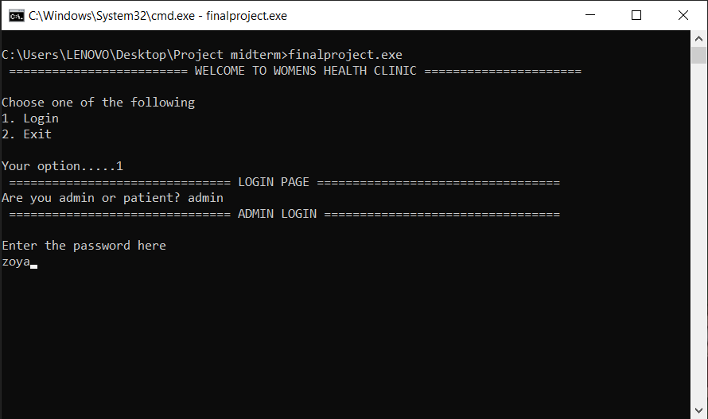

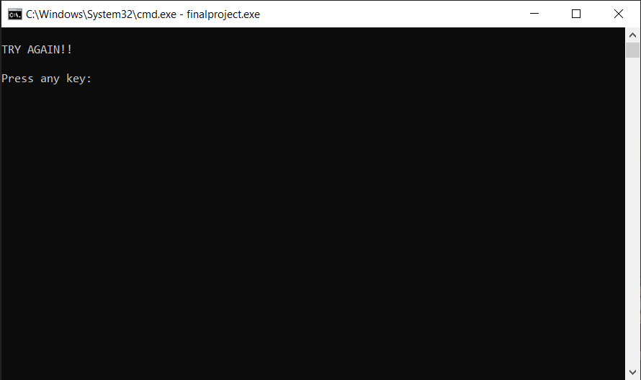

If chooses option 1:

If chooses option 2:

If chooses option 3:

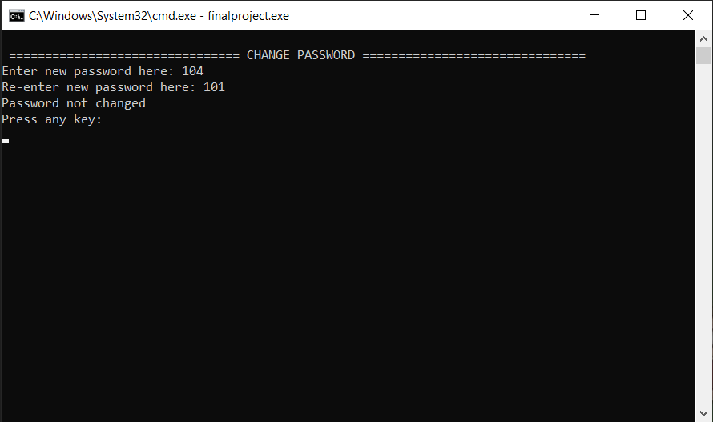

If chooses option 4:
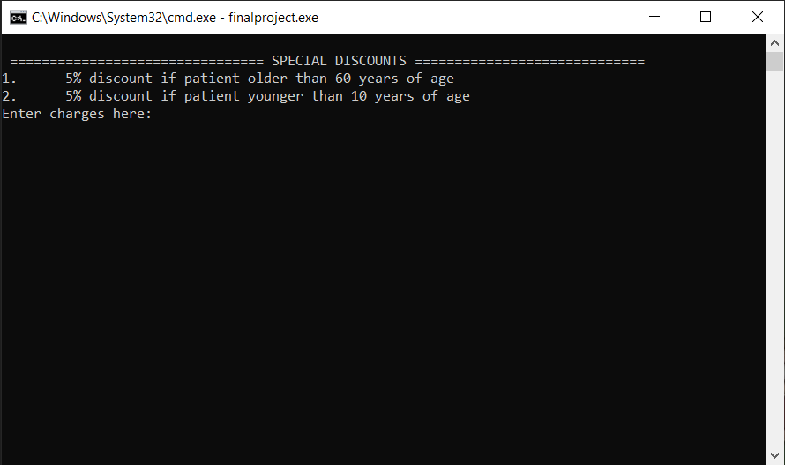

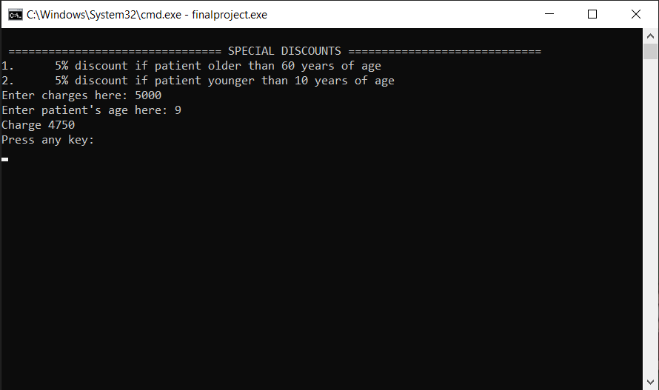

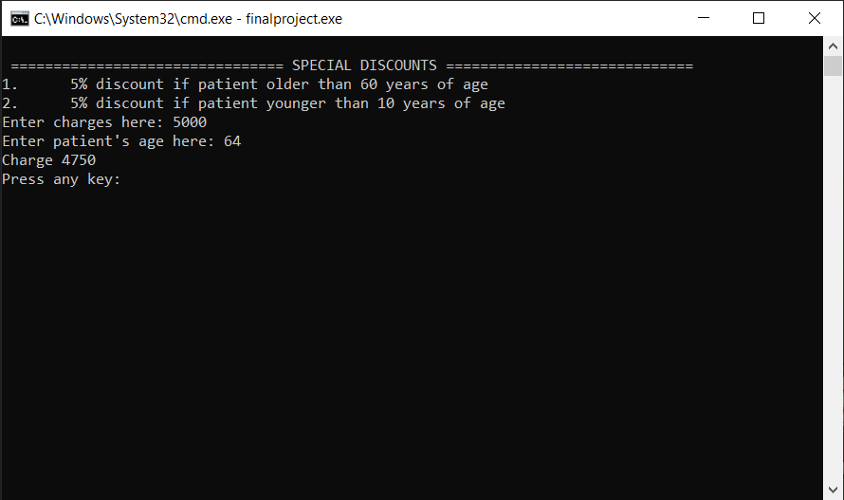

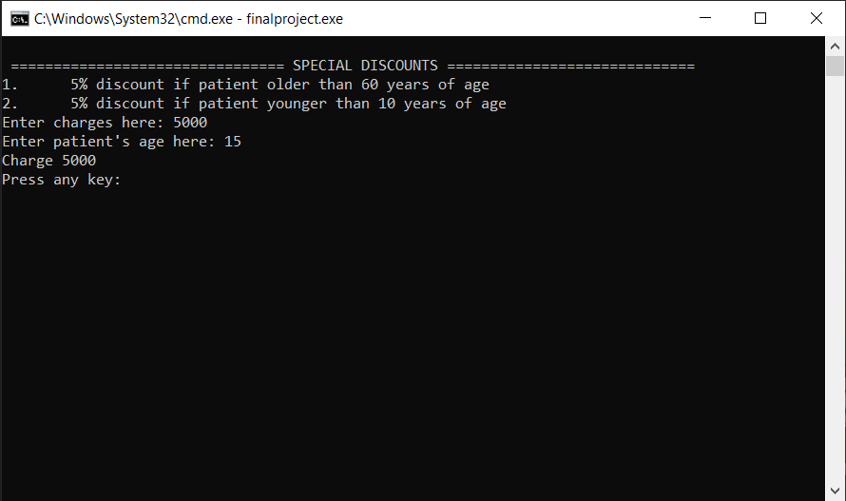

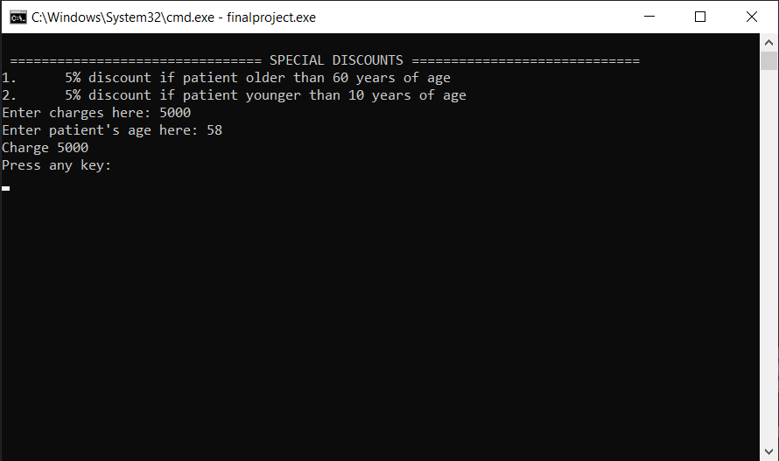

If chooses option 5:

If chooses option 6:
If chooses option 7:

If chooses option 8:
If chooses option 9:
Patient’s login:

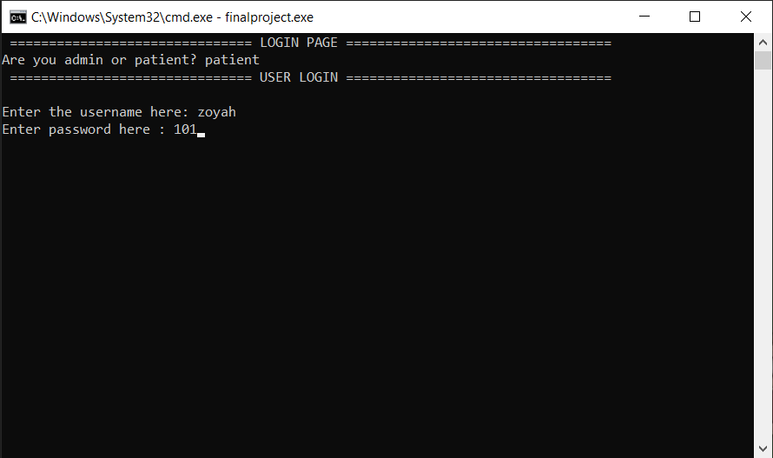

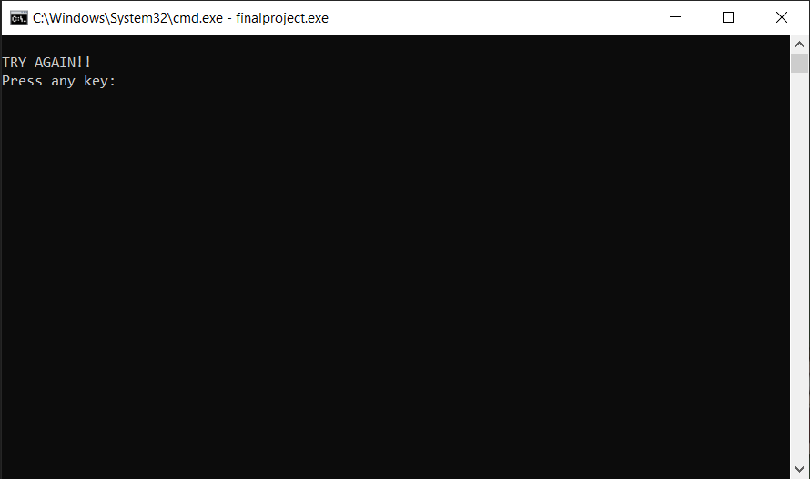

If chooses option 1:

If chooses option 2:

If chooses option 3:
If chooses option 4: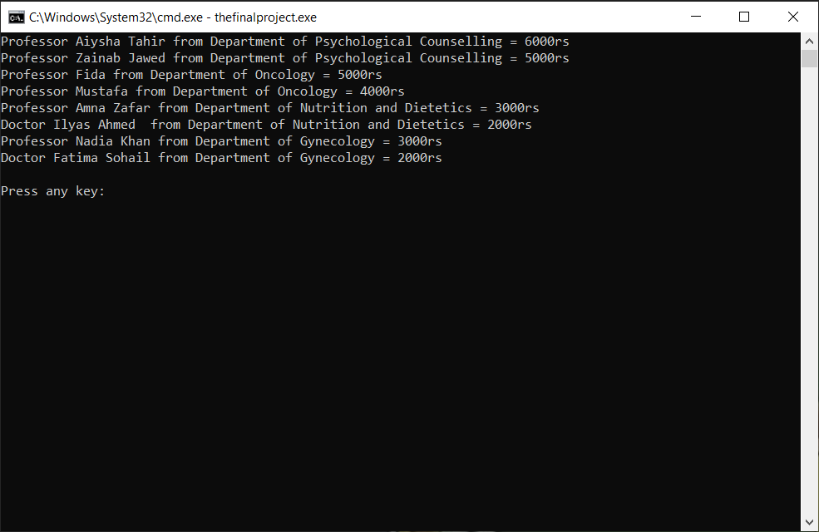
If chooses option 5:
If chooses option 6: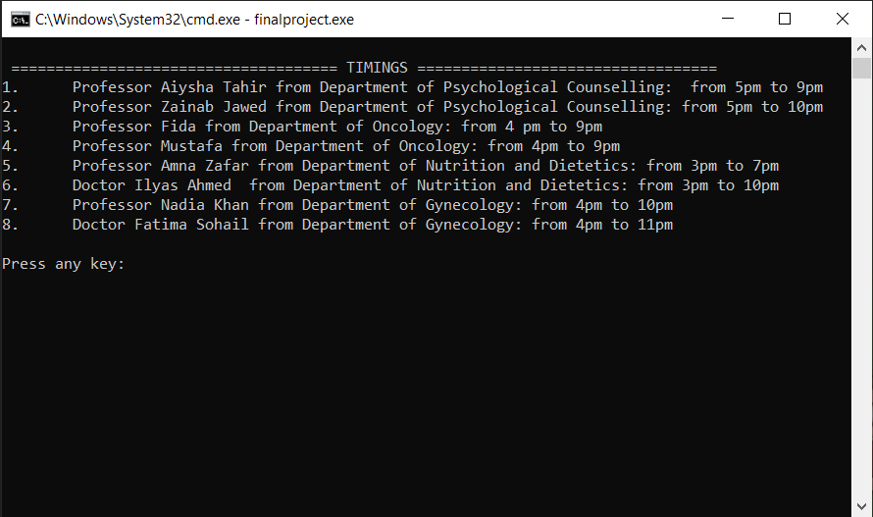
If chooses option 7:

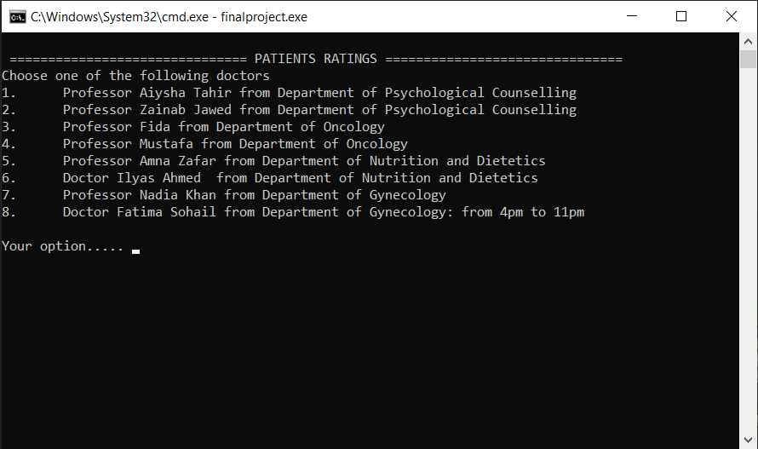

If chooses option 8:

If chooses option 9:

